1. Log into the computer with the provided account.
2. Open up Photoshop 2022 or Illustrator 2022 (or other Adobe app)
3. Each person will need to create a “free Adobe ID”
   1. Click “Create an Account”
   2. Then fill out this information

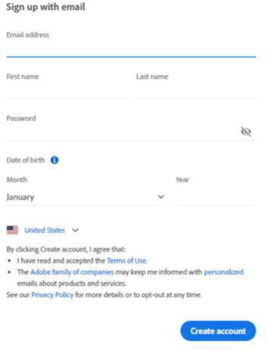

* 1. Click “Create account”

1. This will allow them to use Adobe products.